UTAH DIVISION OF AIR QUALITY
Marginal Ozone Inventory
northern wasatch front, ut
june, 2020

UTAH DIVISION OF AIR QUALITY MARGINAL OZONE INVENTORY

Introduction
On October 26, 2015, the Environmental Protection Agency (EPA) promulgated revisions to the National Ambient Air Quality Standards (NAAQS) for ozone. The EPA strengthened the ozone primary and secondary NAAQS from 75 ppb to 70 ppb, based on the three-year average of the annual 4th highest daily eight-hour average concentration.

On August 3, 2018, EPA designated three ozone nonattainment areas (NAAs) in Utah. The Northern Wasatch Front (NWF), Southern Wasatch Front (SWF), and the Uinta Basin (UB). A map of the three NAAs is shown in Figure 1 below (see 83 FR 25776, "Additional Air Quality Designations for the 2015 Ozone National Ambient Air Quality Standards”; Final Rule, August 3, 2018). All three areas in Utah are currently classified as marginal based on the 2014-2016 design value and other data (see Table 1 for classification thresholds).

Ozone production is a year-round phenomenon, and the highest ozone levels generally occur during the summer when strong sunlight, high temperatures, and stagnant meteorological conditions combine to drive the chemical reactions and trap the air within a region for several days. This is the case for high monitored ozone concentrations on the Wasatch Front.

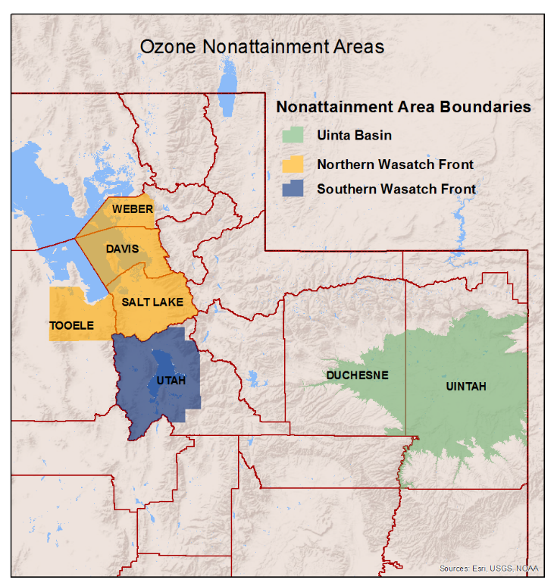
Figure 1: Utah's Ozone Nonattainment Areas
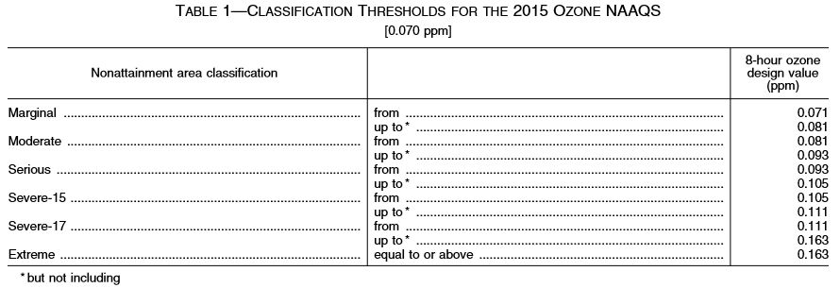

The EPA published the Implementation of the 2015 National Ambient Air Quality Standards for Ozone: Nonattainment Area State Implementation Plan Requirements in December 2018 (see 83 FR 62988). The ozone implementation rule details State Implementation Plan (SIP) requirements for each classification. Table 2 details the SIP requirements for Utah’s marginal areas with due dates.

Federal Requirement | Description | Due Date
40 CFR 51.165 | Marginal Ozone Offset Requirement for VOCs at 1.1:1 ratio | August 3, 2021  40 CFR 51.1314 New Source Review Requirements
40 CFR 51.1314 | Emission Statement Rule | August 3, 2020
40 CFR 51.1315 | Emission Inventory Requirements | August 3, 2020
Table 2: Marginal Ozone Requirements

40 CFR 51.1315 requires states to submit a base year inventory two years after a nonattainment designation. The base year inventory means a comprehensive, accurate, current inventory of actual emissions from sources of VOCs and NO_{X} emitted within the boundaries of the NAA as required by CAA section 182(a)(1). The base year for this SIP submittal is 2017, which is the most recent calendar year for which a complete triennial inventory was submitted to the EPA. The inventory is compiled in ozone season day emissions, which is an average day’s emissions for a typical ozone season work weekday. This is an average July day for the Wasatch Front.

This document gives a brief overview of the baseline emission inventory. The other marginal ozone requirements will be addressed in separate documents. The technical support documentation accompanying this SIP submittal details inventory development of each source category.

Geographic Area
Emissions are typically calculated for area and mobile sources on a county-by-county basis. The boundaries of the three ozone NAAs in Utah do not follow county lines and are complicated by partial counties, elevation boundaries, and jurisdictional boundaries. For all source categories, inventories were compiled statewide to ensure the inclusion of all pollutants including short-range transported pollutants. In addition, although this is the marginal baseline inventory, this data year will be used as the baseline inventory in the event that any of the NAAs are reclassified to moderate status and an attainment SIP is required. The raw inventory data is entered into an emissions processing model and assigned a geographic location (grid cell). To report emissions specific to the NAAs, the Utah Division of Air Quality (UDAQ) will use a GIS description for each area to retrieve the respective emissions data after it has been gridded into the model.

Pollutants
The inventoried pollutants include NO_{X}, VOCs, and carbon monoxide (CO). NO_{X} and VOCs are the only pollutants required by the implementation rule, but CO is an important pollutant for modeling, and is therefore included in this inventory in preparation for a moderate reclassification.

Temperature and Relative Humidity for Mobile Source Emissions
Mobile emissions modeling requires diurnal temperature and relative humidity profiles that are representative of the region of interest in order to accurately reflect vehicle operating processes such as cold starts and idling.

Because the Wasatch Front experiences ozone exceedances sporadically throughout the summer months, a single temperature and relative humidity profile is not representative of an ozone event. For this inventory, an average of county temperature and relative humidity throughout the month of July 2017 was used.

Emission Source Categories
CAA Section 182(b)(1)(B) requires a baseline emissions inventory for NO_{X} and VOCs from all anthropogenic sources in the NAA to be included in ozone SIPs for purposes of rate of progress/reasonable further progress (RFP) demonstrations. This would include any anthropogenic wildfire emissions as well. Since this is not an RFP demonstration, wildfire emissions are not included in this inventory. However, wildfire emissions will be included in any future baseline inventory for an attainment or RFP SIP. Biogenics are an important source of VOCs and will be included in any future ozone modeling as well. Source categories that are included in this inventory are: Area, Point, On-Road Mobile, and Non-Road Mobile.

Area Source
Area source emissions were calculated by county on a ton per year basis using UDAQ area source emissions calculation workbooks which serve as the basis for 2017 National Emissions Inventory data. Area Sources are typically smaller, yet pervasive sources that do not qualify as point sources under the relevant emissions cutoffs. Area sources encompass more widespread sources that may be abundant, but that, individually, release small amounts of a given pollutant. Examples include dry cleaners, residential heating and cooling, auto body painting, and consumer solvent use. Area source emissions are estimated as a group rather than individually using processes (i.e. fuel combustion) and activity data (including population, employment, VMT, fuel usage, animal, crop, oil and gas industry throughput submissions, etc.) to estimate emissions.

Point Source
Point Source emissions are represented as the actual 2017 emissions from the source-reported numbers in UDAQ’s SLEIS (State and Local Emissions Inventory System) database. Any source that has the potential to emit greater than or equal to 100 tpy of NO_{X} or VOCs in the state of Utah is included in the point source inventory. The point source actuals are reported in tons per year. There are 53 point sources in the State of Utah, with 15 in the NWF NAA, two point sources in the SWF NAA, five in the UB NAA, and 31 outside of any ozone NAA.

On-Road Mobile Source
On-road mobile source emission inventories were prepared by the metropolitan planning organizations (MPOs) for the urban NAAs, the Utah Department of Transportation provided the rural nonattainment county inventories, and UDAQ provided rural attainment area inventories for the remaining 20 counties in the State. Inventories were developed in tons per day for an average summer weekday for the Wasatch Front NAAs. Each MPO is responsible for developing the latest planning assumptions for the MOVES 2014b model. The Technical Support Documentation will explain what specific local planning assumptions were used.

Non-Road Mobile Source
Non-road mobile source emissions were calculated for the entire state by county. EPA’s most current MOVES model (MOVES2014b-Nonroad) was used to obtain emission inventories for nonroad mobile vehicles and equipment that operate on unpaved roads or other areas using the temperature and relative humidity profiles discussed in the previous section. This includes lawn and garden equipment, construction equipment, engines used in recreational activities, portable industrial, commercial, and agricultural engines. The EPA estimates emissions related to aircraft activity for all known U.S. airports. Diesel locomotive activity is submitted by railroad companies in units of locomotive diesel fuel consumption (gallons per year) by county.

SMOKE Emissions Model and Processor
UDAQ used SMOKE (Sparse Matrix Operator Kernel Emissions) v4.7 emissions processing software to prepare this inventory in order to normalize all emissions into tons-per-day and to extract inventories specific to the each NAA. SMOKE takes the annual, county-wide emissions inventories prepared by UDAQ and reformulates them for use in the air quality model. The reformulation includes temporal processing, spatial processing, and speciation. Temporal processing converts emissions from annual to daily and hourly values. Spatial processing locates emissions from the county to specific grid cells within the modeling domain. Speciation breaks VOC emissions into their component subspecies, which will eventually be necessary for photochemical ozone modeling.

NWF NAA Ozone Season Day Emissions in Tons Per Day
 | 2017 Emissions (tons per day)
Sector | NOx | VOC | CO
Area Sources | 0.98 | 46.55 | 3.17
Mobile Sources | 52.46 | 28.56 | 290.98
Non-Road Sources | 15.66 | 16.49 | 256.67
Point Sources | 18.83 | 5.88 | 8.8
Total | 87.93 | 97.48 | 559.62
Table 3: NWF Ozone Season Day Emissions

